H.T No
Regulations:
A22

Sreenidhi Institute of Science and Technology
(An Autonomous Institution)
Code No: 9B510 Date: 28-January-2025 (AN)

B.Tech III-Year I- Semester External Examination, January-2025 (Regular)
KINEMATICS OF MACHINERY (MECH)

Time: 3 Hours Max.Marks:60

Note: a) No additional answer sheets will be provided.
b) All sub-parts of a question must be answered at one place only, otherwise it will not be valued.
c) Missing data can be assumed suitably.
Bloom's Cognitive Levels of Learning (BCLL)

Remember | L1 | Apply | L3 | Evaluate | L5
Understand | L2 | Analyze | L4 | Create | L6

Part - A Max.Marks: 6x2=12

Answer all QUESTIONS, EACH QUESTION CARRIES 2 MARKS.

 |  | BCLL |  | CO(s) | Marks
1 | Explain the terms: Lower pair & Higher pair |  | L2 | CO1 |  | [2M]
2 | What is instantaneous centre of rotation? How do you know the number of instantaneous centres in a mechanism? |  | L3 | CO1 |  | [2M]
3 | Explain why two Hooke’s joints are used to transmit motion from the engine to the differential of an automobile. |  | L3 | CO2 |  | [2M]
4 | Which follower programme do you recommend for a high-speed cam and why? |  | L4 | CO3 |  | [2M]
5 | What are the main tooth profiles of gear teeth which fulfil the law of gearing? |  | L3 | CO2 |  | [2M]
6 | What is the effect of centrifugal tension on the tight and slack sides of a belt drive? |  | L4 | CO2 |  | [2M]

Part – B Max.Marks: 6x8=48
ANSWER ALL QUESTIONS. EACH QUESTION CARRIES 8 MARKS.

 |  | BCLL | CO(s) | Marks
7. | Describe various inversions of a slider-crank mechanism giving examples. | L3 | CO1 | [8M]
 | OR
8 | What are quick-return mechanisms? Where are they used? Discuss the functioning of any one of them. | L3 | CO1 | [8M]
9. | In a four-link mechanism, the crank AB rotates at 36 rad/s. The lengths of the links are AB = 200 mm, BC = 400 mm, CD = 450 mm and AD = 600 mm. AD is the fixed link. At the instant when AB is at right angles to AD, determine the velocity of (i)​ The mid-point of link BC (ii)​ A point on the link CD, 100 mm from the pin connecting the links CD and AD. | L3 | CO1 | [8M]
 | OR
10 | 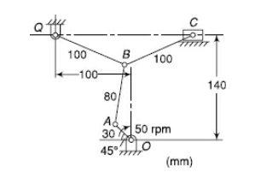A toggle mechanism is shown in Figure along with the dimensions of the links (in mm). Find the velocities of the points B and C and the angular velocities of links AB, BQ and BC. The crank rotates at 50 rpm in the clockwise direction. | L3 | CO1 | [8M]
11 | What is fundamental equation of steering gears? Which steering gear fulfils this condition? Explain in detail. | L2 | CO2 | [8M]
 | OR
12 | The driving shaft of a Hooke’s joint runs at a uniform speed of 240 r.p.m. and the angle α between the shafts is 20°. The driven shaft with attached masses has a mass of 55 kg at a radius of gyration of 150 mm.  i). If a steady torque of 200 N-m resists rotation of the driven shaft, find the torque required at the driving shaft, when θ = 45°. ii). At what value of ‘α’ will the total fluctuation of speed of the driven shaft be limited to 24 r.p.m ? | L3 | CO2 | [8M]
13 | A cam is to give the following motion to a knife-edged follower :  i ). Outstroke during 60° of cam rotation ; ii). Dwell for the next 30° of cam rotation ;  iii). Return stroke during next 60° of cam rotation, and iv). Dwell for the remaining 210° of cam rotation. The stroke of the follower is 40 mm and the minimum radius of the cam is 50 mm. The follower moves with uniform velocity during both the outstroke and return strokes. Draw the profile of the cam when the axis of the follower passes through the axis of the cam shaft. | L3 | CO3 | [8M]
 | OR
14 | A cam, with a minimum radius of 25 mm, rotating clockwise at a uniform speed is to be designed to give a roller follower, at the end of a valve rod, motion described  i) To raise the valve through 50 mm during 120° rotation of the cam ;  ii). To keep the valve fully raised through next 30°; iii) . To lower the valve during next 60°; and iv ). To keep the valve closed during rest of the revolution i.e. 150° ;  The diameter of the roller is 20 mm and the diameter of the cam shaft is 25 mm. Draw the profile of the cam when (a) the line of stroke of the valve rod passes through the axis of the cam shaft. The displacement of the valve, while being raised and lowered, is to take place with simple harmonic motion. Determine the maximum acceleration of the valve rod when the cam shaft rotates at 100 r.p.m. | L3 | CO3 | [8M]
15 | A pair of involute spur gears with 16° pressure angle and pitch of module 6 mm is in mesh. The number of teeth on pinion is 16 and its rotational speed is 240 r.p.m. When the gear ratio is 1.75, find in order that the interference is just avoided ; 1. The addenda on pinion and gear wheel ; 2. The length of path of contact ; and 3. The maximum velocity of sliding of teeth on either side of the pitch point. | L3 | CO2 | [8M]
 | OR
16 | 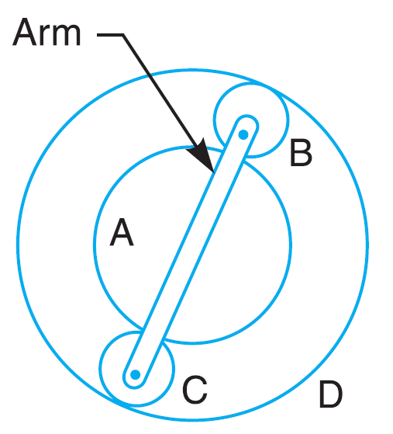An epicyclic train of gears is arranged as shown in Fig. How many revolutions does the arm, to which the pinions B and C are attached, make : 1. when A makes one revolution clockwise and D makes half a revolution anticlockwise, and 2. when A makes one revolution clockwise and D is stationary ? The number of teeth on the gears A and D are 40 and 90 respectively. | L3 | CO2 | [8M]
17 | An engine, running at 150 r.p.m., drives a line shaft by means of a belt. The engine pulley is 750 mm diameter and the pulley on the line shaft being 450 mm. A 900 mm diameter pulley on the line shaft drives a 150 mm diameter pulley keyed to a dynamo shaft. Find the speed of the dynamo shaft, when 1. There is no slip, and 2. There is a slip of 2% at each drive. | L3 | CO2 | [8M]
 | OR
18 | Two pulleys, one 450 mm diameter and the other 200 mm diameter are on parallel shafts 1.95 m apart and are connected by a crossed belt. Find the length of the belt required and the angle of contact between the belt and each pulley. What power can be transmitted by the belt when the larger pulley rotates at 200 rev/min, if the maximum permissible tension in the belt is 1 kN, and the coefficient of friction between the belt and pulley is 0.25 ? | L3 | CO2 | [8M]
-- 00 -- 00 –

